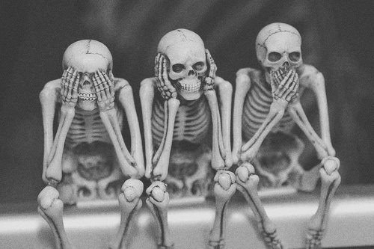 Eternal Sleep Paranormal
PUBLICATION/WEBSITE MEDIA PERMISSON FORM
Please fill out and sign the appropriate statement to either give or to decline permission to use pictures, video recording and any other media on any of Eternal Sleep Paranormals media outlets.

To GRANT permission:
I _______________________(Please print your name) Grant permission for Eternal Sleep Paranormal to pulish photos, videos recording and any other media taken of my establishment/facility or residence, ___________________________ __________________________________________________________________
- I give Eternal Sleep Paranormal the perpetual, royalty-free right to use the establishment/facility names as well as any form of media in any non-derogatory manner including but not limited to pulications and websites.
- I understand that both the various publications and websites have a large audience and my child’s photo will be available to the general public.
- I futher state that I have to give this permission.
- I understand that if I give notice to the webmaster that I object ot any particular picture on the website, it will be removed as soon as possible.
- Publication of these photos on webites may include first names for the identification purposes unless I check the box below that I do not give permission for the names to be used ____Please DON’T include first names with photos on websites.

To REFUSE permission:
I ____________________ (Please print your name) REFUSE to grant permission for Eternal Sleep Paranormal to publish any media involving my establishment/facility: ________________ _____________________________________________________________________________

SIGNED _____________________________
DATED____/____/____

