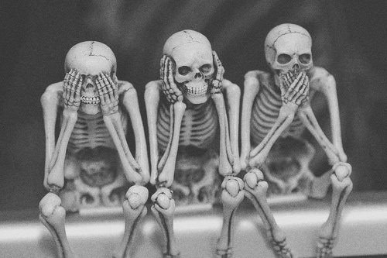 Eternal Sleep Paranormal
Eternal Sleep Paranormal members follow a strict Code of Conduct during all investigations
- No smoking on investigations as this may create false ecto mist pictures.
- Avoid taking pictures in the rain, snow, high winds, or when fog is present. This may also create false anomalies to appear on pictures.
- When breath is visible due to cold weather, ecto mist pictures will be considered to have a natural explanation.
- Camera straps should be placed around the neck or wrist, or removed before a picture is taken. This will avoid the camera strap getting in front of the lens and creating false vortex-like pictures.
- Avoid taking pictures of reflective objects, as flash reflections can cause false anomalies on film and video.
- Be aware of dusty locations, and allow dust to settle before photographing.
- During warmer months, be aware of insects, humidity, and pollen floating in the atmosphere. All of these can create anomalies that look to be paranormal.
- Always clean camera lenses and equipment before and after each investiagion. Check camera lenses during an investigation and make sure they are not smudged, fogged, or dusty.
- When taking pictures, always look for cobwebs floating in the air or stretched between two objects. Spider webs can create a line that looks like a streak of light on your picture.
- Be aware of animals in the area. Animal eyes can relect and cause green or orange dots on your pictures. Also beware that when using a night shot video camera, the eyes will glow and reflect bcause of the infrared light.
- No drus or alcoholic beverages at any time.
- Don’t use vulgar language while investigating.
- Cemeteries, buildings, houses, or any other location that we investigate will be treated with respect and left undisturbed.
- Always survey the investigation site in advance. Look for reflective surfaces, background lights, dangerous areas, places to set up equipment, and power lines or any other man made source that might interfere with your EMF meter or other equipment.
- Never investigate alone
- Setup a controlled environment when possible. Monitor everything and know where each investigator is at all time.
- Be extremely quit during investigations, especially while trying to capture voices on audio tape (EVP)
- Avoid strong smelling colognes or perfunes. Ghost or spirits sometimes make there presence known by certain smells
- Always write down time and location of any paranormal event, including any unusual smells, feelings, or noises that you might encounter.
- When trying to capture EVP, write down the natural noises you hear in the back ground so you will not confuse it with something else later
- When trying to capture EVP, always survey the surrounding area for people, and carsparked with the radio on.
- Always researchthe history of the location that oyu are investigating.
- Interview any witnesses that have experienced paranormal activityat the location being investigated. Write down, in detail, their experiences.
- Look at all natural explanantions before determining that what you have found is something paranormal. Be skeptical but open minded.

____________________________
Signature
__________________
Date

