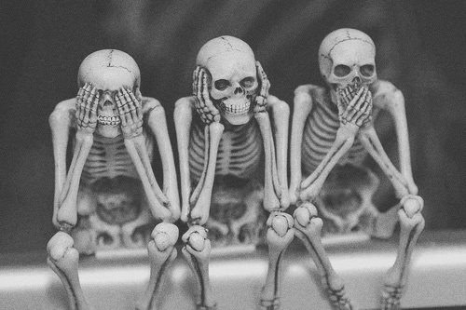 Eternal Sleep Paranormal
ACCIDENT WAIVER AND RELEASE OF LIABILITY FORM
Name of the Activity or Event: __________________________________________
Date of Activity or Event: ______________________________________________
ETERNAL SLEEP PARANORMAL AND IT’S AFFILIATES ASSUMES ALL OF THE RISK OF PARTCIPATING AND/OR VOLUNTEERING IN THIS ACTIVITY OR EVENT, including by way of example and not limitation, any risks that may arise from negligence or carelessness on the part of the entities being released from dangerous or defective equipment or property owned, maintained, or controlled by them, or because of their possible liability without fault.
- I certify that all persons in my group are physically fit, have sufficiently prepared or trained for participation in the activity or event, and have not been advised to not participate by qualified medical professional.
- I certify that there are no health-related reasons or problems which preclude my participation in this activity or event.
- I acknowledge that this accident waiver and release of liability from will be used by the event holders, sponsors, and organizers of the activity and responsibilities at said activity or event.
- In consideration of my application and permitting me to participate in this event, I hereby take action for myself, my executors, administrators, heirs, next of kin, successors, and assigns as follows:

- ETERNAL SLEEP PARANORMAL AND IT’S AFFILIATES WAIVE, RELEASE, AND DISCHARGE from any and all liability, including but not limited to, liability arising from the negligence or fault of the entites or persons released, for my death, disability, personal injury, property damage, property theft, or actions of any kind which may hereafter occur to me including my traveling to and from this event, the following entities or persons:
_______________________________________________And/or their employees

- ETERNAL SLEEP PARANORMAL AND ITS’S AFFLILIATES INDEMNIFY, HOLD HARMLESS, AND PROMISE NOT TO SUE the entities or persons mentioned in this paragraph from any and all liabilities or claims made as a result of participation in this activity or event, whether casued by the negligence of release or otherwise. Iacknowledge that the ______________and their directors, officers, representatives, and agents are not responsible for the errors, omissions, acts on failures to act of any party or entity conducting a specific event or activity on behalf of the ______________________________________________

